**Science Week Little STEM Challenge**

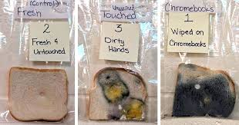**Experiment:: Growing Mould**

**Materials:**

• Water

• Tape tape

• Leftover foods (like bread, oranges, lemons, apples, grapes, red peppers, courgettes, cauliflower, cheese or biscuits)

• Clear container with a lid (a big glass jar or a big clear plastic container works best)

**What you need to do:**

NOTE: This is a great project to keep a log or record on your findings each day that you check for changes.

1.  Place the jar on its side.

2.  Cut around 3 to 5 different pieces of food into small chunks about 1.5cm (1 inch.).

3.  Dip all the different pieces of food into the water.

4.  Spread the foods out in the jar so that they are not in a pile.

5.  Place the lid on the jar and tape around the outside of the lid to seal it

6.  Place the jar where it will not get knocked over or thrown away.

7.  Put a label with the date on the jar

8.  Keep a check on the food in the jar.

**Safety First!**

**\*\*\* DO NOT USE anything with meat or fish in it. After a few days these foods would start to smell very bad.\*\*\***

Did you know you…Mould is everywhere. ..there are over 100,000 different types of mould. Mould can grow on many surfaces and it starts growing in 24 to 48 hours!